Around the World with Upton and Grant:
Military Touring and Sino-American Relations in the Nineteenth Century

Isaac Hurley

Introduction
When in October 1875, American Major-General Emory Upton set foot in Shanghai, he found a weakened and unstable nation, “delivered over to weakness, cruelty, ignorance, and superstition.” Upton arrived in China on behalf of the US Government, as part of a tour of Asia and Europe to study foreign armies. While not the first American fact-finding mission to China, his visit, followed four years later by former president, General Ulysses S. Grant, represented the crossover of several major trends within the late 19th century. First, the prominence of “World Touring”, extended transnational journeys which had grown in popularity over the century; and, second, the reconstruction of American policy post-Civil War, and the terminal decline of the Qing Dynasty in China. Their visits reflected deeply on the mutual desire for reconstruction, in which an interest in international affairs and foreign exchange within the United States mixed with China’s growing importation of foreign expertise in their respective post-war eras. Upton’s examination of the many failings of the Qing forces served as a cautionary tale for US military planners, while Grant was treated to symbolic projections of military power and diplomacy. Despite their difference in motives and fame, these tours and their relationship with China originated in the aftermath of extreme conflict, forcing both societies to put military interests as key priorities in the decades to follow.
In the mid-nineteenth century, much of the world had found itself gripped in an era of heightened separatism, in which both nationalist causes and the state’s will to supress them grew substantially. Few civil wars of the era compared to the United States or Qing China, both of which incurred mass casualties (The Taiping Rebellion dwarfing others with a death toll of twenty to thirty million) and social upheaval. A new generation of political leaders rose from these conflicts based on their ability to tackle both insurrection and foreign threats. In the Chinese context, leaders such as Li Hongzhang (1823-1901) and Prince Gong (1833-1898) came to prominence for their ability to create modernised, effective armies in putting down the Taiping. Likewise, leaders in the American war effort came to prominence in the post-Civil War era in both government and military posts, such as President and former General Ulysses S. Grant and Major General Emory Upton. With Upton earning the rank of Major General by 1864, and having instigated reforms within the military by 1867 with Grant’s approval, and Ulysses S. Grant gaining the presidency in 1869, both used their experiences in the Civil War to strengthen American security at home and abroad.
Statemen in both countries felt they could learn from one another’s experiences. Despite the deep cultural, political, and economic divides between the two nations, mutual interest in military reform prompted major fact-finding world tours. What follows focuses on Upton’s tour of China in 1875 and Grant’s in 1879. This work analyses what Americans and Chinese officials sought to gain through these tours, their interactions and discussions of military policy, and the cultural divides which altered their perspectives. To do so, it examines mass media, private correspondence and government records generated by and about these tours. While American popular media focussed on the symbolic and ceremonial actions which projected the state of both Chinese and American military powers. Private correspondence and records like those in Upton’s Armies of Asia and Europe both offer more material observations of the nature of defence, while government documents seen in The Papers of Ulysses S. Grant shed light on diplomatic concerns and the interests the US and China had in the Asia-Pacific region during these tours.
The study of these two tours contributes to two separate historiographies. Firstly, their place within the phenomenon of World Tours in the 19th century. In his exploration of World Touring, Dane Kennedy notes how primarily western travellers were guided by both ideological goals, like those of European exceptionalism, and as a means to fuel the growing boom in travel literature. However these tours are unique in their motives, as instead of a means of signalling good relations between states or cultural exchange, they were instead guided by technical goals such as information gathering or measuring support. Even while Grant’s tour was highly publicised by the mass-media, Upton’s work remained more obscure outside of US military circles. Even during the more diplomatic motives of Grant’s visit, he conceded America’s place in China not as an ally but only as the “least hated” Western power.
Secondly, this study places these tours within the greater decline and fall of Imperial China from its defeat in the First Opium War in 1832 to the Empire’s overthrow in the Xinhai Revolution of 1911. The devastation of the Taiping Rebellion and the encroachment of colonial powers such as Britain, Japan and France placed the Chinese empire at risk. Through this we can see how Chinese officials during the “Self-Strengthening Movement”, which sought to reform the Qing Dynasty and its army to defend itself, both sought Western advancements in military policy while also attempting to prevent itself being subject to the same nations’ colonial designs.

Emory Upton and the Army of China
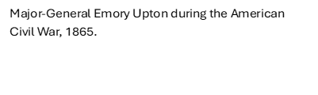
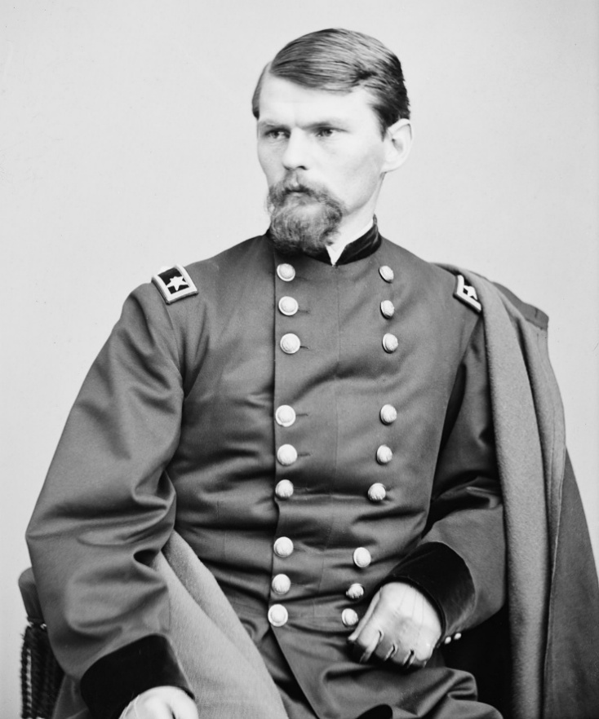
General Emory Upton’s relationship with China preceeded his tour in 1875. Aware of China’s decline, he had begun to contemplate the idea of constructing a Western-style military academy in China by the early 1870s, and to help precure Western weaponry and strategy in the nation in imitation of Japan’s example. Alongside the need for technological advancements, his own personality and ideology influenced his perspective. A devout Christian, Upton noted China’s need to adopt Christianity in order to advance to a similar status of the Western world. Despite these qualms, he offered to the American consol in Tianjin, “I would like to help China forward in the way of progress, and, should she summon me to her service, I will give to her ten of the best years of my life.”
Despite his request, he was denied and turned his attention to reforming the US military, a part of a wave of Union military leaders whom President Grant wished to reward with leading positions in the post-war era. However, later in the decade his journey to China would be realised. In the mid-1870s Upton was ordered to journey across Europe and Asia, a tour that would start in Japan and end in Britain, in order to “Examine and report upon the organization, tactics, discipline, and the manoeuvres, of the armies along the route mentioned,” The tour was ordered by General William Tecumseh Sherman, who noted how the growing populations and modernisation of Asian states like Japan represented the “reflux tide” of power growing in Asia, something the United States sought to observe with growing interests in the nineteenth century. For Upton, the tour was an opportunity to reflect on the United states’ own internal weaknesses. For Upton, Qing China mirrored the United States own failings in the Civil War, lamenting “We have rejected the practice of European nations and with little variation, have thus far pursued the policy of China.” Through his tour, he sought to rectify American military flaws which he saw reflected in the Qing Empire, and emulate the successes of Europe which he witnessed later in his tour.
Departing from his first stop in Japan aboard the ship Costa Rica, Upton reached Shanghai in October, 1875. From the very start he notes the undertones of Sino-Western tensions that underscored his visit, discussing how the “Chinese are throwing up long lines of batteries, as if to intimidate the foreigners by threatening their communications.” Much of Upton’s comments regarding Sino-Western tensions throughout his report manifests itself through China’s sentiment towards Christianity. He repeatedly makes note of the numerous massacres suffered by missionaries and their converts. Even in other non-Christian states, the repression of local converts takes priority in his more cultural observations, such as in his final notes on Japan. These comments continue throughout his account.
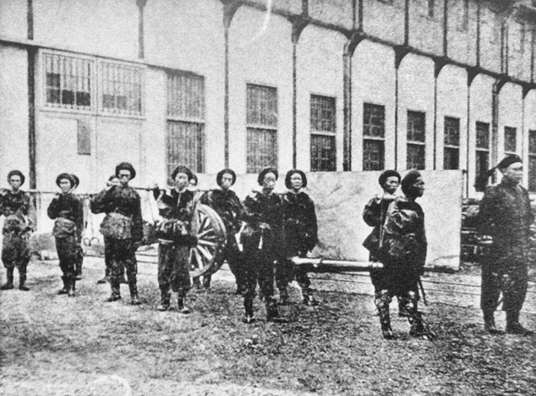
Next come his more technical analyses. When allowed to view a drill of the local forces in Shanghai, he dismisses it as a mere “burlesque” of a drill. “Lacking intelligence” and organisation, in which groups of Chinese soldiers wandered and talked among themselves before firing into the air randomly and accompanied by a poorly played band. Ending when soldiers “both individually and in squads, wandered back to the city.” As Upton’s first introduction with the Chinese infantry, he was deeply unimpressed. Even further he notes how those within the Chinese army were shunned by wider Chinese civilization, as the “refuse of society,” who lacked proper wages or status.
Qing Soldiers during the Self-Strengthening Movement in Shanghai, home to several Westernised arsenals, 1880s.
His view of the officers was no better. When Upton arrived in Guangzhou in November, he witnessed the trials for electing officers of the Qing army, being based upon feats of physical strength instead of leadership skills, and facing harsh punishments when failing examinations. Upton noted how many of these examinations fail to account for the warfare of the nineteenth century, with tests of archery and cavalry instead of education or modern military technology. While the unfamiliarity with firearms is attested, it is also worth noting the lack of attention Upton pays towards internal ethnic tensions between Han Chinese footmen and their Manchu officers, despite tensions between the ruling minority Manchus against the ethnic majority Han. However, he does make a poignant observation in the proliferation of opium addiction within the Chinese ranks, stating, “The use of opium, which has already become formidable, bids fair, if not checked, to entirely destroy the efficiency of the army.” In part a result of China’s loss in the Opium Wars, the proliferation of opium among the Chinese further represented the failure of the Qing state to defend itself against foreign powers such as the British, while failing to mention the foreign role in the Qing’s opium epidemic.
As an initial analysis of China’s army, Upton’s view was almost entirely negative. He regularly presents the Chinese army as disorganised, primitive and unable to adequately counter any threat to the state. While much of this may fit in the Orientalist perspective of Upton’s time, his views of China’s technological stagnation are not entirely unconvincing. Even with the presence of Westernised arsenals, these would have struggled to modernise and equip an army Upton estimates to be up to a million men across the empire. Furthermore, the locations of these Westernised forces, typically in China’s urban centres, meant that forces on the Qing border largely remain limited, as shown later in his travels outside the Great Wall. This poses the question as to why Upton sought to learn from such an army, and why Chinese officials such as Li Hongzhang and Prince Gong sought to host him. However, his later writings make his motive evident, the Chinese army served as an example for the United States to avoid, and his criticisms offered the Qing state a view into how to reform its army.
The interest in mutual aid can be observed in the Chinese procurement of American arms. When visiting Tianjin, Upton notes the presence of arsenals of American Remington rifles constructed with English machinery, with other such armouries in Shanghai and Nanking. These stocks show how the Qing state was both open to US advisors and American imports to strengthen its military, particularly during the rush for Western technology and knowledge during the “Self-Strengthening Movement”. It also coincided with China becoming a growing market for American goods and industry.
Furthermore, Upton’s analysis of Chinese campaigns outside the Great Wall against nomadic steppe societies offer implicit comparisons to America’s own conflict against the indigenous peoples. Traveling on horseback over the Great Wall, he struggled to navigate “the rugged pass, which was obstructed by hundreds of camels going and returning from Mongolia”, lamenting how the presence of modern forts would prove more effective than the ancient walls. Noting how the lack of suitable infrastructure impaired China’s ability to fight against the “warlike Circassians”, having to rely upon large convoys of camels and mules instead of rail or waterways, one can see implicit comparisons to American expeditions into the largely underdeveloped territories, particularly during President Grant’s attempt to enforce the newly created reservation system and continue the costly war in the underdeveloped western territories. Much like in the America’s western territories, Upton argued that only “with railroads and telegraphs leading to her frontiers” could the Qing sufficiently enforce its rule on the empire’s fringes.
While his comparison to the American-Indigenous wars were limited by his lack of experience in the conflict, his analysis both of the Qing’s performance in the Taiping rebellion and its prospects in a future rebellion echoed his views of the Union’s ability during America’s own civil war.
In his report he recalls the Taiping rebellion, in which “Ill-fed, ill-paid, ill-clothed, […] Government troops struggled in vain to suppress the revolt,” Both in his report and later writings, this parallel with American forces becomes apparent. In his analysis of American forces during the Civil War in the posthumously published Military Policy of the United States, he wrote: “the Regular Army, […], was too remote to participate in the first shock of arms or even to provide a sufficient defence for the capital.” This opens the main critique Upton had of both Chinese and American forces, their dispersal forces across the country limited their ability to supress localised rebellions. The Provincial Governors of China and the State Governors of the United States crippling their abilities to raise forces under the weight of bureaucracy, with China only surpassing the American army in its corruption. While Upton’s observations reveal both the American interpretation of the Chinese army and its use to the United States, we can also observe what his Qing hosts sought to gain through Upton and other advisors’ expertise, as seen in his letters detailing encounters with Qing officials.
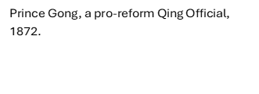
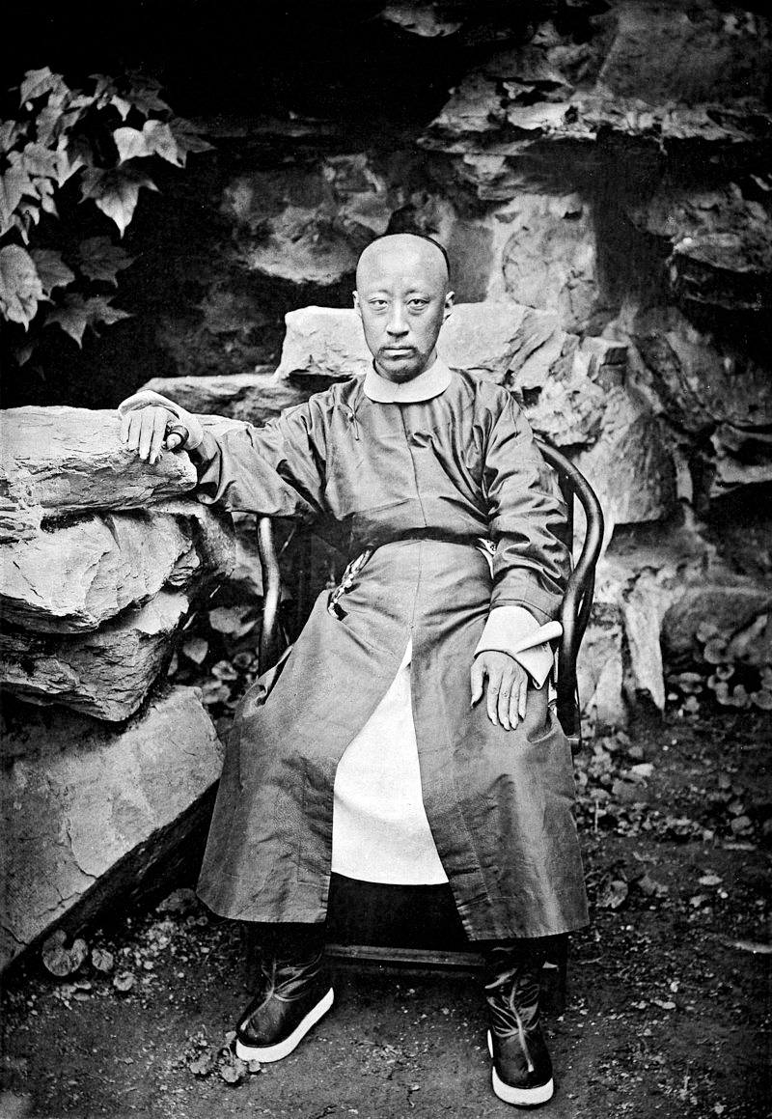
On the 5th of October, Upton entered Beijing, the “famous city of Kublai Khan.” Taking note of both the ancient fortresses alongside the crumbling infrastructure and destitute populations which sullied any praise he had for the imperial capital. The city was also marked with reminders of foreign incursions into China, such as the burnt remains of the formerly lavish Summer Palace, destroyed by British forces in 1860. Here Upton met two post-Taiping officials, Prince Gong and Li Hongzhang. While his description of his meeting with the prince is limited, Upton’s meeting with a high-ranking official of the Qing showed the Chinese state’s interest in Western advisors. In turn Gong suggested for Upton to meet Li Hongzhang, the spearhead of China’s “Self-Strengthening” movement. Upton’s interaction with Li is revealing. In a meeting on the 10th, he records Li’s lamentation of “the feeble condition of China, the necessity of a military academy, and the organization of a large army.” Mirroring Upton’s previous attempt at establishing Westernised military academies within China, he urged the “generalissimo” to follow the Japanese example, which had embraced Western doctrines and training.
His final visit to the Taku Forts furthered his push for the Westernisation in China. Visiting the coastal forts on October 30th, Upton noted the German artillery and advisors alongside the rare occasion China was able to defeat a foreign power, the British, in 1860 at the Fort, showing how China could indeed defeat its foreign advisories. Despite this, final reflections on China were pessimistic, pondering if China would remain an “independent nation or, […] the vassal of a nobler people.”

Grant and Diplomacy in China
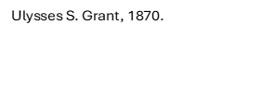
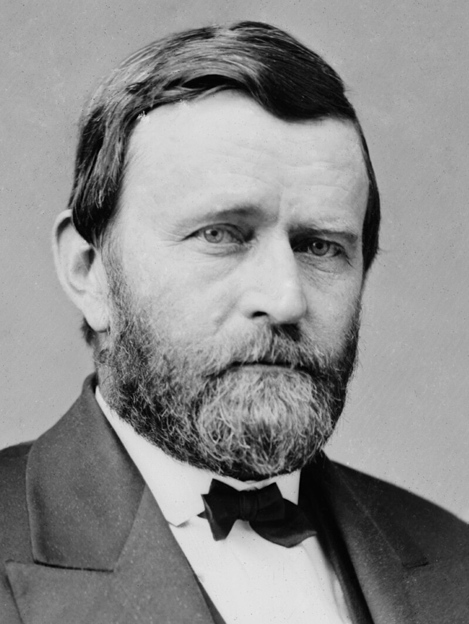
While Upton’s journey provided a technical study of Chinese forces, Grant’s visit in 1879 was a far more prominent and symbolic journey. Instead of Upton’s more focussed visits, Grant was treated to displays of power and discussions of diplomacy from the 21 cannon salutes delivered by Chinese warships to urgings from Chinese official for his mediation in conflicts with Japan. Much like Upton, Grant’s tour in China was a part of a greater transnational journey across Asia and Europe. Again, China’s hosting of Grant was contradictory, for China sought to host foreigners to gain their technology and expertise in order to avoid subjugation from those same foreign powers. However, as Sherman had warned Upton, Grant noted how China’s industrial progress could create a great power within the Far East which could potentially rival its foreign enemies.
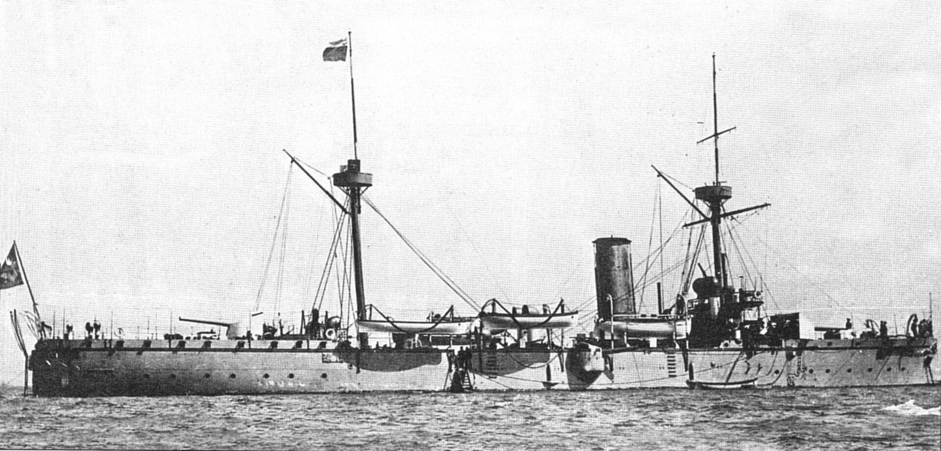
The start of his journey signified Grant’s reputation as a military leader, which surpassed his image even as a former president. Subjected to ceremonies of miliary pomp, the USS Ashuelot on which he travelled in Asia was treated to cannon salutes delivered by Chinese gunboats upon his entry to Guangzhou on the 5th, which his escorting vessel returned. While these displays seemed inconsequential, they signified both attempts of good-will between China and the United States and China’s strengthening naval presence, which was supplemented by purchasing American and European made vessels.
A Chinese Gunboat similar to those encountered by Grant, modernised under Li Hongzhang’s reforms, 1880s.
Grant was regularly confronted by the foreign presence in China. When he set foot in Shanghai on 17 May 1879, he was greeted by “almost the entire foreign community and a large number of Chinese.” Much like Upton, Grant was deeply conscious of Sino-Western tensions during his tour, believing it was China’s own weakness which led to its domination by foreign powers, and sympathising with China’s desire to “drive out all Europeans – American included”, if only China developed the military capabilities to do so. While the press wrote of Grant drawing large crowds, he himself spoke of the disinterest the Chinese had in his presence. While parading through Guangzhou a week before, he noted how working-class Chinese would fail to even acknowledge the “barbarian” presented to them. As previously stated, despite displays of good-will, Grant was conscious that America merely represented China’s “least hated” Western power.
In June, Grant made his way into Beijing, describing the capital ominously as the “forsaken city”, despite noting the industrialisation and reform of Chinese society, in his brief descriptions Grant describes the city as a place of “precious little to interest.” It was here he met with the high-ranking reformer Prince Gong. Indeed, this industrialisation and its military repercussions became a subject of interest in their meeting. Having spent much of his inland travels via waterways, Grant proposed the use of rail as a means to ease travel across the vast empire. Informing the Prince how “The value of railroads is to disseminate a nation's wealth and enable her to concentrate and use her strength. [...] We cannot be sieged, broken up and destroyed in detail.” Much as Upton concluded, Grant found China’s lack of infrastructure a glaring failure in its defence. However, the means to which America built its rail, with vast numbers of migrant workers from China, would come to be a point of contention later in his tour.
His conversation with Prince Gong ended with the topic of China’s international struggles. Viceroy Hongzhang had made an appeal for Grant to act as a mediator between China and Japan. Japan’s annexation of the Chinese tributary Ryukyu Islands in 1872, caused Li to look to Grant as a potential negotiator in his later tour to Japan. Despite these pleas, Grant seemingly had little understanding of China’s system of tributary states. He further stated to Prince Gong his lack of interest in intervening in Asian affairs as a private citizen. This was despite Gong’s warning that such a conflict would damage America’s previously mentioned commercial interest in China. In the end, Grant’s interaction with Prince Gong showed how Qing officials aimed to use Grant’s tour to improve its international security, even if it amounted to little.
However weak the Chinese military was, or how fragile Sino-American relations remained, this did not prevent Qing officials using Grant’s visit to their advantage, or Qing displays of military power. His reputation as a General led to Chinese officials seeking his insight, particularly on military matters. Following Upton’s footsteps, Grant sought to meet the “Generalissimo” Li Hongzhang. While on route through the “unattractive” countryside waterways to Tianjin in early June, two Chinese gunboats sent on behalf of Hongzhang escorted Grant’s vessel. Such posturing showing how central military matters would be to their meeting.
When the two men finally met, their discourse covered much of the complex Sino-America relationship. Li and Grant discussed the topic of Chinese immigrants to the United States and growing anti-Chinese sentiment. Despite this tension, Grant leveraged his reputation as a General to justify the resistance to Chinese immigrants, claiming, “The trouble about your countrymen coming to America is that they come under circumstances which make them slaves. […] We had slavery some years since, and we only freed ourselves from slavery at the cost of a dreadful war.” By framing the dispute as a continuation of the abolitionist cause, this interaction shows how Grant utilised his military image in diplomatic matters during his tour of China.
Furthermore, he noted how his experience of the Civil War alongside the whole nation made Americans uniquely useful in reforming China’s army, stating that the “war had been an educator,” making American officers uniquely valuable to China. Even more interesting was his reference to Upton and his visit, recalling both his visit and failed attempt to establish an academy in China. Using him as an example of America’s value, he proclaimed, “General Upton is a distinguished and able officer. General Upton has a high rank in our regular army, especially for a young man, […] there is no nation in the world where there are so many competent military men as in America.”
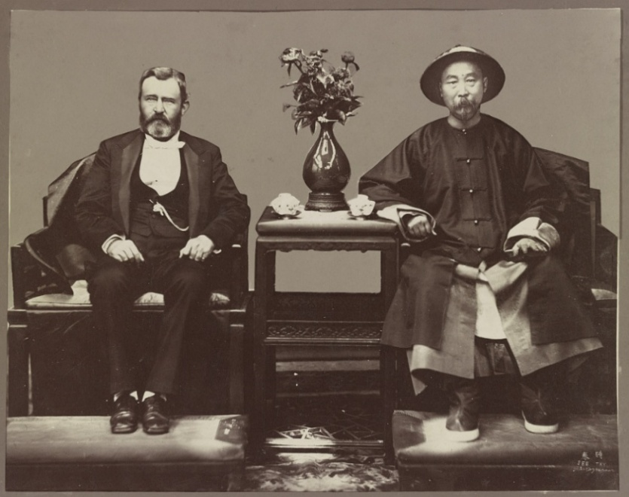
His meeting with the famed Viceroy, whom Grant recognised as one of the “great men” he met along his tour, marked the last stop on his tour, leaving China upon the USS Richmond. In contrast to Upton, Grant was optimistic about China’s future, writing in his final letter that it was “on the eve of a great revolution that will land her among the nations of progress.”
Conclusion
Grant and Li Hongzhang, 1879.
The decades that followed appeared to vindicate Upton, nonetheless. In 1900, American marines intervened to suppress the Boxer Rebellion with fellow imperial powers, in 1911 the Qing dynasty collapsed, and further encroachments by Japan followed until 1945. In 1972, almost a century after the visits of Upton and Grant, another American visited China. When Richard Nixon arrived in Beijing, the tables had turned. Now the American military had began to faulter in its war in Vietnam, and China and become the powerbroker in Cold War Asia. The legacy of the tours during the 1870s having continued decades later, showing the importance of American role in Asia, and despite the “Century of Humiliation” brought by the West, China’s place in it.
Grant and Li Hongzhang, 1879.
Alongside the contemporary ramifications, these tours provide insight into how touring influenced China’s place in the world during the 19th century. Both Upton and Grant describe a nation in decline, with territory sought by foreign powers and an ineffective government failing to defend itself. As these tours have shown, the more pragmatic, transactional motives are highly relevant in understanding the motives for World Touring, as it was not merely an exercise in diplomacy or cultural exchange but also one of information gathering, which in the Chinese context contributed to a project of applying both the diplomatic and military insights provided by Western tourers into a larger goal of modernising the Qing state and its defence. Both tours and their descriptions complement each other in providing insight into China’s reforms and America’s place within them. With a mutual experience of war among both the American tourers and their Chinese hosts, military matters became the dominant topic of conversation.

Emory Upton, ‘The Armies of Asia and Europe’, (London: D. Appleton, 1878), p.32.
David Prior, ‘Reconstruction, from Transatlantic Polyseme to Historiographical Quandary’, in Reconstruction in a Globalizing World, ed. by David Prior, (New York: Fordham University Press, 2018), p.177 (pp.172-208).
Don Doyle, ‘Secession As an International Phenomenon: From America's Civil War to Contemporary Separatist Movements’, (Athens: Georgia University Press, 2010), p.13.
Tobie Meyer-Fong, ‘What Remains: Coming to Terms with Civil War in 19th Century China’, (Stanford: Stanford University Press, 2013), p.13.
Doyle, Secession, p.6.
Robert Bickers, ‘The Scramble for China: Foreign Devils in the Qing Empire, 1832-1914’, (New York: Penguin Random House, 2012), p.181.
David John Fitzpatrick, ‘Emory Upton: The Misunderstood Reformer’, (Michigan: UMI, 1996), p.125.
Ibid, p.157.
Dane Kennedy, ‘Reinterpreting Exploration: The West in the World’, (Oxford: Oxford University Press, 2014), pp.17-18.
John Y. Simon, ‘The Papers of Ulysses S. Grant, Volume 29: October 1, 1878-September 30, 1880’, (Carbondale: Southern Illinois University Press, 2008), p.171, via <https://scholarsjunction.msstate.edu/cgi/viewcontent.cgi?article=1027&context=usg-volumes> [Accessed 28 September 2025].
Fitzpatrick, Upton, p.238.
Ibid.
Peter Smith Michie, James Harrison Wilson, ‘The Life and Letters of Emory Upton, Colonel of the Fourth Regiment of Artillery, and Brevet Major-General, U.S. Army’, (New York: D. Appleton And Company, 1885), p.291. via <https://www.google.co.uk/books/edition/The_Life_and_Letters_of_Emory_Upton_Colo/ZsjTAAAAMAAJ?hl=en&gbpv=0> [Accessed 28 September 2025].
Fitzpatrick, Upton, p.182.
Stephen McCullough, ‘Avoiding War: The Foreign Policy of Ulysses S. Grant and Hamilton Fish, in A Companion to the Reconstruction Presidents, 1865–1881’, ed. by Edward O. Frantz, (Chichester: John Wiley & Sons, 2014), pp.373-391, (p.379).
Michie, Wilson, Life and Letters, p.299.
Ibid, p.301.
Emory Upton, ‘The Military Policy of the United States’, (Washington: Government Printing Office, 1912), p.VIII, via <https://www.google.co.uk/books/edition/The_Military_Policy_of_the_United_States/ExISAAAAYAAJ?hl=en&gbpv=0> [Accessed 16 October 2025].
Fitzpatrick, Upton, p.228.
Upton, Armies of Asia and Europe, p.385.
Ibid, p.384.
Ibid, pp.20-21.
Ibid, p.21.
Ibid, p.21-22.
Ibid, p.22.
Charles W. Hayford, ‘New Chinese Military History, 1839–1951: What’s the Story?’, Frontiers of History in China, Vol.13, No.1, pp.90‒126, (p.100).
Ibid.
Upton, Armies of Asia and Europe, p.23.
Ibid, p.19.
Ibid, p.28.
Bickers, The Scramble for China, p.192.
McCullough, Avoiding War, p.379.
Upton, Armies of Asia and Europe, p.391.
Ibid.
Ibid, p.26.
Eric Moser, ‘Flames in the West: American Expansion, Federal Indian Policy, and the Transformation of Indigenous Lives in the Age of Grant, in A Companion to the Reconstruction Presidents, 1865–1881’, ed. by Edward O. Frantz, pp.354-572, (pp.357-359).
Upton, Armies of Asia and Europe, p.31.
Ibid, p.30.
Upton, Military Policy, p.226.
Fitzpatrick, Upton, pp.255-256.
Upton, Armies of Asia and Europe, p.388.
Ibid.
Ibid, p.391.
John L. Rawlinson, ‘China’s Struggle for Naval Development, 1839–1895’, (Cambridge: Harvard University Press, 1967), p.63.
Ibid, p.390.
Ibid.
Ibid, p.394.
Ibid, p.32.
Edwina S. Campbell, ‘Citizen of a Wider Commonwealth: Ulysses S. Grant's Post-Presidential Diplomacy’, (Carbondale: Southern Illinois University Press, 2016), p.160.
McCullough, Avoiding War, p.452.
Ibid, p.147.
Rawlinson, China’s Struggle, p.67.
‘Gen. Grant in the East: Travelling in China and Siam, His Reception in the Celestial Empire’, New York Times, June 17th, 1879, p.1, via < https://www.nytimes.com/1879/06/17/archives/gen-grant-in-the-east-traveling-in-china-and-siam-his-reception-in.html?searchResultPosition=1> [Accessed 28 September 2025]
Campbell, Citizen of a Wider Commonwealth, p.147.
Ibid, p.150.
Simon, Papers of Ulysses S. Grant, p.171.
Ibid, p.146.
Ibid.
Ibid, p.143.
Samuel C. Chu, Kwang-Ching Liu, ‘Liu Hung-Chang and China's Early Modernization’, (New York: Taylor and Routledge, 1993), pp.165-167.
Ibid, p.167.
Simon, Papers of Ulysses S. Grant, p.155.
Ibid, p.154.
Ibid, p.147.
Ibid.
Simon, Papers of Ulysses S. Grant, p.159.
Ibid, p.160.
Ibid.
Chu, Liu, Liu Hung-Chang, p.167.
Campbell, Citizen of a Wider Commonwealth, p.168.
Ibid.

