Lala Lajpat Rai’s Second American Tour

Saniyah Mazhar

When Lala Lajpat Rai stepped onto the campus of Tuskegee University in 1916, he was not a curious tourist; he was a scholar in exile, searching for answers. As he wrote, “One of the things that prompted me to pay a second visit to the United States… was my desire to study the Negro problem on the spot and to acquaint myself with the methods that are being adopted for the education and uplift of the Negro population.” Witnessing education wielded as a tool for dignity and transformation in Alabama, Rai saw a mirror of Punjab’s struggle against caste and colonial rule. He explicitly noted “some analogy between the Negro problem… and the problem of the depressed classes in India,” finding the social problems, “in some of its phases very similar.” This experience crystallised his belief that Indian liberation required not only agitation, but also the institution-building and educational empowerment he studied at Tuskegee.
As a Panjabi, whose discipline tends to be focused on the Americas, I came to this project looking for revolutionaries in my past. My academic interests have always centred on transnational resistance and the politics of exile, but this research gave me something deeper. An opportunity to follow the path of a fellow Panjabi who, like me, ventured into uncharted terrain in pursuit of education, solidarity, and new means for resistance.
Known as the “Punjabi Kesari”, the Lion of the Punjab, Lala Lajpat Rai was a leading figure in the early Indian nationalism movement. By the time he departed for the United States in 1914, he was already under surveillance, restricted, and imprisoned by the British authorities for his vocal support of Indian self-rule. He did, however, develop some of his radical and global beliefs during his exile during this tour.
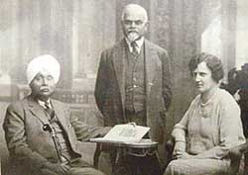
Figure 1: Lala Lajpat Rai (far left) at a meeting of the Fabian Society
This second American tour, taken at the height of the First World War, was a formative intellectual and political journey for Rai. Over four years, Rai immersed himself in the political and reformist life of the United States. He engaged deeply progressive thinkers like W.E.B. Du Bois, Booker T. Washington and Walter Lippmann, participated in public debates, published widely, and founded the India Home Rule League of America and the Young India journal. His tour was neither an attempt to win over the elite nor a diplomatic charm offensive. As a means of relocating the Indian nationalist struggle inside a larger global discourse of freedom, it was, instead, an intentionally anti-colonial intervention from the beginning.
Rai’s political thought before 1914 was already shaped by Indian debates on education, swaraj (self-governance), and Hindu reform, but his American experience sharpened these views and transformed him into an internationalist. He began to speak of racial and caste hierarchies as structurally parallel systems, and envisioned independence not just as political separation, but as social transformation. His comparison of American racial segregation and Indian caste oppression marked a radical move. One that linked India’s freedom to wider global movements against inequality.
This post asks what Rai’s American tour adds to our understanding of world touring, not as cultural diplomacy, but as a political strategy. It shows how exile became a site of influence, not marginalisation, and how Rai used international space to reshape the narrative of empire. He was not a tourist of global institutions, nor a deferential colonial subject seeking recognition. His anti-colonial touring style was confrontational, comparative, and committed to the oppressed across borders.

Strikingly, Rai’s biographers have largely glossed over this period, focusing instead on his domestic activism in India. Similarly, the broader literature on Indian world touring emphasises cultural exchange or elite figures seeking validation from imperial metropoles. Rai’s American years resist these narratives. His tour was not about the prestige of the West, but about challenging it, and using its contradictions to amplify India’s voice.
By revisiting this underexplored episode of Rai’s life, this piece aims to add nuance to the historiography of Indian nationalism and global resistance. It offers Rai not just as a historical figure, but as a lens through which to understand how colonised subjects used international mobility not to escape empire, but to fight it, strategically, vocally and transnationally.

Building Networks and Organisations
When Lala Lajpat Rai arrived in the United States in late 1914, he was neither a diplomat nor a representative of any official Indian body. He was, undeniably, a political exile. But for Rai, exile was not a time for retreat; it was an opportunity to understand, compare, and build.
He noted his unsettled vividly in his Lajpat Rai Autobiographical Writings, “I have seen and lived at times for months in some of the biggest cities of the world… I have witnessed the highest achievements of what passes under the name of modern civilisation… I have met numerous men, good, bad and indifferent, some of them the cream of the modern world…”
At the same time, Rai was clear-eyed and unflinching in his assessments of fellow Indian activists abroad. At an early dinner in New York, he described the venue as untidy, the food poor, and remarked on the dubious company of certain attendees, including a suspected spy. Politically, and personally, he chose distance over diplomacy.
Rai quickly realised that charismatic speeches and informal networks would not suffice. Individual appeals were fleeting, as they lacked the scale and structure. Instead, he needed an institutional foundation. And so, in 1917, he founded the India Home Rule League of America, based in New York.
The League’s mission was ambitious but clear:
- To educate Americans about the true nature of British rule in India;
- To reframe India’s national aspirations through American democratic ideals;
- Create a hub for diaspora Indians, especially students and political exiles, to find intellectual solidarity and practical support.

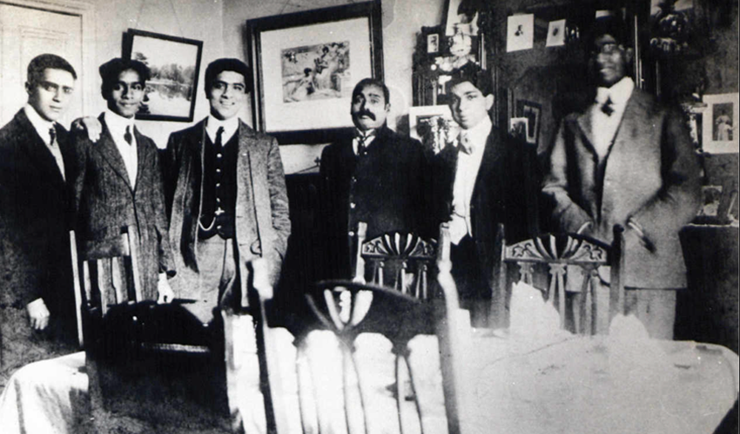
Figure 2: Lala Lajpat Rai (centre) with Indian Students at the University of Cambridge.
Image courtesy of the Nehru Memorial Library and Museum and Dr Vanya Vaidehi Bhargav.

The League challenged British colonial narratives through lectures, pamphlets, and media engagements, creating a cohesive Indian presence on U.S. soil. Rai portrayed Indian nationalists not as radicals or extremists, as many British outlets suggested, but as progressive reformers seeking peaceful, constitutional self-governance.
Even after Rai returned to India in 1919, the League sustained itself. American figures like Jabez T. Sunderland, a Unitarian minister and long-term ally of Indian self-rule, carried forward its operations. This demonstrated that the League was not Rai’s vehicle; it had become a durable, transnational institution.
In sum, Rai’s American years show how he used exile not as exile, but as a form of strategic repositioning. He combined astute cultural observations with political clarity. His early travelogue writing revealed admiration for the U.S. and critical awareness of Indian diaspora divisions. This balanced perspective fuelled his belief that Indian freedom could be pursued from within the colony and from the heart of the imperial metropolis itself.

Young India: Media as Anti-Colonial Strategy
Founded in 1916 by Lala Lajpat Rai while he was in exile in the United States. Young India was far more than a journal. It served as a way to advocate, teach, and organise. Through its pages, Rai tried to correct the stories told by the British Empire and put the Indian independence fight in a way that was in line with democratic ideals around the world. The magazine, which was put out by the India Home Rule League of America, became a voice for Indian nationalism worldwide, especially among Americans. Though short-lived in this early incarnation, the British authorities banned it in England and India; Young India left a lasting intellectual legacy. Its themes, rhetoric, and strategies anticipated many arguments that animated India’s mass movements in the 1920s and 1930s.
The issues of Young India from December 1918 and January 1919 give us a great look into Rai's mind at this significant time. They show a man with strong moral beliefs and a smart understanding of building and keeping a cause going while being limited by colonialism. Rai was deeply invested in forging international alliances, but he was equally focused on shaping the minds and habits of Indians abroad. His strategy fused emotional appeals with economic analysis, and rhetorical power with organisational clarity.
In the December 1918 editorial, Rai offers a sweeping portrait of India as a civilisational power unjustly diminished under colonial rule. He writes, “India is a land of wealth, beauty, and profound intellect… nearly one-fifth of humanity lives within her borders… and yet she suffers under impoverishment and illiteracy.” The contrast here is deliberate and pointed. Rai positions India not as a helpless colony, but as a nation whose current degradation is a historical and moral aberration. The grandeur of India’s past is not invoked for nostalgia’s sake, but to demonstrate the sheer scale of the injustice perpetrated under British rule. In Rai’s framing, it is an ethical contradiction that demands resolution.
What is striking about Rai’s appeal is how quickly he moves from this broad civilisational canvas to a call for practical, daily engagement from his readers. In the January 1919 editorial, he proposes that every Indian in America “hand in his or her room a small map of India with figures of mortality, income and education, written in large characters.” This map, he writes, should be the first thing seen in the morning and the last thing viewed at night. Rai’s instruction here is more than symbolic; it is a psychological tactic. He is asking diaspora members to tether their daily routines to the ongoing suffering of their homeland. This, for him, is what commitment looks like, not periodic gestures, but constant consciousness.
Rai’s conception of freedom was also grounded in material realities. He was particularly attuned to the economic dimensions of colonialism. In the same January 1919 edition, he declares, “Economic bondage is the worst of all bondages… One person economically dependent upon another is a virtual slave.” In this line, Rai is not merely stating an opinion, but rather, he is articulating a principle. Political independence, in his view, is hollow without economic sovereignty. His critique of British monetary policy, especially the manipulation of India’s tariff system to benefit British manufacturers, clarifies that he saw imperialism as a political injustice and a system of sustained economic exploitation.
Rai’s focus on fiscal autonomy culminates in his assertion that “there can thus be no autonomy without fiscal autonomy… the latter alone is the determining characteristic of an autonomous existence.” This was a radical claim in its time. Many moderate nationalists still imagined a future for India within the imperial framework, perhaps with incremental concessions. Rai, by contrast, insisted that anything short of full economic self-determination would leave India trapped in a state of dependency. His use of words like “bondage” and “slavery” is not a rhetorical excess; it is a deliberate strategy to dramatise the stakes of the struggle.
These editorials reveal Lajpat Rai as a pragmatic strategist whose moral appeals were carefully calibrated for distinct audiences. His invocation of shared democratic values was a deliberate tactic to win the sympathy of American progressives and internationalise the Indian cause. Simultaneously, he directed a separate, more exacting message to the Indian diaspora, demanding “a life of incessant sacrifice and toil.” This was not a contradiction but a coherent strategy where he sought to build external pressure on the British Empire through foreign sympathy, while forging internal discipline within the movement itself. Thus, his work transcended simple moralism, representing a sophisticated, two-front campaign for legitimacy and liberation.
Ultimately, Young India was a platform for what Rai called “education and consolidation.” Its purpose was to counter British propaganda and galvanise Indians into ethical, strategic, and sustained action. The issues from December 1918 and January 1919 show a man determined to turn pain into purpose and disappointment into discipline. We can see that Lajpat Rai was a leader who knew freedom would not just be given; it had to be built daily through words and actions.

Encounters and Alliances in America
During this period, Lala Lajpat Rai’s journey across the United States, from the lecture halls of Berkeley to the corridors of the Tuskegee Institute in Alabama, and from the vibrant intellectual circles of New York to the political hubs of Washington D.C., immersed him in a world of political possibility and profound moral contradiction. His physical travel of the American landscape mirrored his intellectual journey, as his encounters with Indian revolutionaries on the West Coast, German agents in the capital, and African American intellectuals in the South revealed the tangled paths to liberation under empire. For Rai, nationalism was not a free pass to violence or opportunism. It required integrity. As he negotiated different ideas about India’s future while moving through these distinct American milieus, he not only became a voice for Indian freedom but also a thinker who connected the fight against colonialism with the struggle for global justice.
From his earliest months in America, Rai was wary of the exiled revolutionaries he encountered. Reflecting on a dinner hosted by Professor B.K. Sarkar and others recalled that “the house or the apartment was extremely untidy, I may say dirty, the crockery black and the cutlery repressive.” While seemingly mundane, this impression symbolised what he saw as the disorder and lack of seriousness within the movement. More troubling was the political company. “S.B. I had always suspected as a spy,” he wrote, and he was alarmed to see him among avowed nationalists.
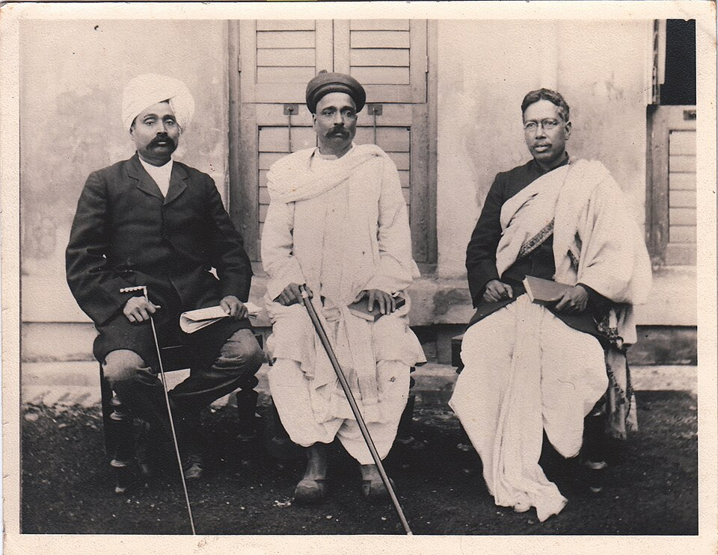
Figure 3: The three pillars of Swarajya - Lala Lajpat Rai, Bal Gangadhar Tilak, and Bipin Chandra Pal or Lal-Bal-Pal. Source: Maharashtra Digital Archives, Wikimedia Commons, URL: https://commons.wikimedia.org/wiki/File:The_three_pillars_of_Swarajya_-_Lala_Lajpat_Rai,_Bal_Gangadhar_Tilak_%26_Bipin_Chandra_Pal_or_Lal-Bal-Pal.jpg
Rai’s discomfort deepened after a public event where a German associate smashed a clay figure of John Bull to symbolise Britain’s destruction. In Rai’s words, “I apologised profusely for the rude conduct of Sekunna and dissociated myself entirely from his sentiments.” Though he remained committed to Indian self-rule, Rai was determined not to associate with “wild talk” or schemes reliant on German military support. “I have been always rather fanatically attached to the theory that liberty won with foreign help was not worth having,” he insisted. In this stance, he sharply differentiated his vision of ethical nationalism from the expedient opportunism of many revolutionaries.
By 1919, Rai had spent five years among exiled Indian nationalists. His final assessment was unsparing. Of the Bengali revolutionaries, he wrote, “Most of them were absolutely unprincipled… Considerations of gain or profit tainted their patriotism.: He criticised their use of revolutionary funds for “luxuries” and noted that many “were anxious to save as much as they could for future use.” In contrast, he found that among Punjabis, particularly Sikh members of the Ghadr Party, “there were better men… They could travel any class. They were any clothes and never bargained. They were truly Khalsa (pure).”
Even those who impressed him ideologically, then disappointed him practically. Ram Chandra, a Ghadr leader in San Francisco, initially offered $3,500 for the defence of Bhai Parmanand and other prisoners. Yet as Rai discovered, “I don’t think that money was ever paid to anyone in India. It is still with me.” He invested the funds instead, treating them as a “sacred trust.” The episode revealed his discomfort with revolutionary rhetoric and the actual handling of resources and accountability.
Lala Lajpat Rai’s intellectual alignment with W.E.B. Du Bois was a calculated political strategy, not merely an expression of solidarity. By requesting documentation of U.S. racial violence for his rebuttal to Mother India by Katherine Mayo, Rai weaponised comparative analysis as a tool of anti-colonial argument. His call for “telling pictures of the cruelties inflicted on your people by the whites of America” sought to make visceral the hypocrisy of Western empires that condemned Indian society while perpetuating systematic brutality at home. This move reframed India’s struggle as part of a global confrontation with racial and imperial power, leveraging transnational empathy to undermine the moral authority of colonial rulers and strengthen the intellectual foundations of Indian sovereignty.
Rai’s vision of Indian independence was anchored in ethics, not just anti-colonial fervour. Even while rejecting British rule, he insisted: “Considering our present circumstances, we would rather stay in the British Empire as a self-government part… than go out to be governed by another nation.” His critique of German-backed revolutionaries reflected mistrust of imperial rivals and a more profound belief that India must shape its future. As he warned Ram Chandra, “outside the ranks of the army, the whole of the Punjab and Karachi could not produce even 5,000 men who had ever seen a rifle, much less a machine gun.” It was not merely folly, but a dangerous illusion.
This clarity extended to his views on democracy. Though many revolutionaries embraced authoritarian ideas under the influence of Nietzsche and theories of the “Superman”, Rai worried that such thinking would produce new tyrannies. He wrote, “most of the Bengali revolutionaries that I met appeared to me to be the believers in the cult of ‘Superman’… They would be the worst possible rulers if the Government of India ever fell into their hands.”
Lajpat Rai’s years in the United States were transformative, not for what they added to his ideological radicalism, but for the way they clarified his commitment to principled resistance. He did not criticise other Indian revolutionaries because he was afraid; instead, he did not want to give up his morals for convenience. In his letters to Du Bois and in combination with his thoughts on political betrayal, he wrote about a strong vision of anti-colonial unity that went beyond race and nationality. Du Bois concluded in his memorial that Rai’s death was not a defeat but a challenge, as he wrote, “out of the blood of his martyrdom very soon a free colored nation will arise.”

“Color-Caste” and Global Anti-Colonial Vision: Rai’s Reflection
Lala Lajpat Rai’s years in the United States between 1914 and 1919 not only provided him with refuge from colonial repression but also profoundly shaped his global political imagination. Nowhere is this more evident than in his detailed reflection on race and caste in The United States of America: A Hindu’s Impression and a Study, where he advanced a powerful analogy between racial segregation in America and the caste system in India. He observed that Americans often spoke of a “color line” to describe racial exclusion.
Rai wrote, “It is remarkable that the original Sanskrit term denoting caste should be equivalent to the English word ‘color’.” To him, this was not a linguistic coincidence but proof that two exclusion systems were built similarly. In both India and America, caste and race were built on the idea that one group was better than another. Social norms, economic status, and the law supported this idea. Although the caste system in India was older and more formally codified, Rai was surprised by how strictly American culture maintained distinction based on race.
Throughout his writings, Rai returned to the theme that while India’s caste system was a moral and social failing, America’s race problem represented a form of modern hypocrisy. He wrote that “Christian whites of the United States of America are doing today, in the 20th century of the Christian era,” what the ancient Brahmin elite once did in India, enforcing the arbitrary system of hierarchy and exclusion. In his view, this made American critiques of Hinduism’s caste system deeply ironic. Christian missionaries, he argued, had little credibility condemning caste while remaining silent on the social stratification in their own country.
Rai’s comparison extended beyond superficial similarities. He noted that social status dictated everything from educational access to marriage rights to court justice in both societies. He was especially shocked that even mixed-race African Americans like W.E.B. Du Bois, fair-skinned and highly educated, could not dine in public restaurants or attend public functions without discrimination. He indignantly wrote, “Dr Du Bois… would not be admitted into any restaurants, hotel, or theatre, in the capital of the Union Government.” Rai interpreted this as evidence that race in America was about social power rather than genetics, which was consistent with his concept of caste in India.
Rai’s travels across the United States were the essential conduit for this political education. It was his physical journey to American institutions like Morehouse College and his direct dialogues with leaders like John Hope and W.E.B. Du Bois that transformed abstract sympathy into a concrete, intellectual alliance. Du Bois subsequently reminisced about Rai with affection, stating in 1929, “When a man of his sort can be called a Revolutionist and beaten to death by a great civilised government, then revolution becomes a duty to all right thinking men.” This connection highlights that his anti-racist endeavours were not developed in isolation in India, but were directly shaped and intensified by the relationships built and the realities witnessed during his travels in America.
What made Rai’s analysis particularly incisive was his simultaneous willingness to critique caste in India with equal force. He did not defend the caste system as uniquely Indian or spiritually justified. Instead, he wrote, “The rigid caste system we have in India is, without doubt, a social curse and cannot but be denounced in the most unmeasured terms.” He asserted that educated Hindus had a responsibility to eliminate “the obnoxious caste barriers that stand in the way of social consolidation, intellectual progress and political advancement.” He had learnt from his time in the United States how dangerous these hierarchies are and how urgent it is to destroy them for national power and morality.
Rai’s critique of American race relations and Indian caste divisions served a larger strategic purpose. It allowed them to frame India’s freedom struggle as a national campaign and as part of a global movement against oppression and inequality. His comparative reflections strengthened his belief in mass education, social reform, and political participation as necessary pillars of a democratic nation. After returning to India, he founded the Tilak School of Politics in Lahore, clearly modelled on American institutions, and launched The People, a newspaper dedicated to social justice and anti-caste thought.
Rai’s belief in the power of international public opinion also emerged from his American experience. He knew India's case for independence could be pushed forward through protests at home, diplomacy and messages sent to other countries. He had seen how Americans reacted to stories of injustice. His public talks and the book Young India helped people understand and care about India's cause by connecting it to other battles worldwide.

Conclusion
Lala Lajpat Rai’s American years were not a detour but a crucible. He found himself in a democracy torn by contradiction in the United States, where some celebrated education. At the same time, millions were denied it, and where liberty was declared, racial segregation was maintained. Instead, Rai carefully examined these inconsistencies and found that American racial relations were a reflection of caste systems in India.
His interactions with Booker T. Washington, W.E.B. Du Bois, and other Black American leaders strengthened this comparative perspective. He gained a more profound knowledge of the connections between education, dignity, and resistance due to these meaningful encounters rather than chance encounters. Like Du Bois, Rai saw emancipation as a moral and political objective. Their thoughts and writings witness their common conviction that sacrifice, knowledge, and the truth can alter.
Rai expressed an internationalist resistance ethics that disapproved of racial dominance, imperial hierarchies, and internal divisions through his thoughts on caste in India and race in America. It was impossible to distinguish his criticism of colonialism from his advocacy for Indian social transformation. He advocated for liberation from economic exploitation, caste prejudice, and exclusionary politics, in addition to the British.
Upon his return to India, Rai did not disregard the lessons of exile. They permeated his journalism, activism, and educational endeavours. The intellectual and moral clarity he acquired in America influenced the institutions he established, his arguments, and his partnerships.
Today, we are challenged to reconsider the geography of anti-colonial ideology by revisiting Rai's voyage to America. It was made in the fields and courts of British India, the lecture halls of Tuskegee, the pages of Young India, and the conversations with Black American revolutionaries. His legacy is not only in India; it is global.

Avinash Hingorani, ‘Lala Lajpat Rai and W. E. B. Du Bois’, in A Clash of Color: Dialogues on Race, Caste, and Solidarity in the United States and India, by Avinash Hingorani (Cambridge: Cambridge University Press, 2024), pp. 63–75.
Lala Lajpat Rai, Autobiographical Writings, ed. by Vijaya Chandra Joshi (Delhi: University Publishers, 1965), pp. 197–222.
The New York Times, ‘Lala Lajpat Rai, “Lion of Punjab,” Dies; Was the Leader of the Nationalist Party in India’s Legislature’, 18 November 1928, https://www.nytimes.com/1928/11/18/archives/lala-lajpat-rai-lion-of-punjab-dies-was-the-leader-of-the.html [accessed 5 August 2025].
Don K. Dignan, ‘The Hindu Conspiracy in Anglo-American Relations during World War I’, Pacific Historical Review, 40.1 (1971): 57–76.
‘Life of Epic Dimensions’, The Tribune (20 November 2005) https://www.tribuneindia.com/2005/20051120/spectrum/main1.htm [accessed 19 October 2025].
Desai, Manan, ‘Oh Niagara! Lala Lajpat Rai at Niagara Falls in 1905’, South Asian American Digital Archive (SAADA), 1 September 2017, https://www.saada.org/tides/article/oh-niagara [accessed 5 August 2025]
Vanya Vaidehi Bhargav, “Introduction,” in Being Hindu, Being Indian, by Vanya Vaidehi Bhargav (Haryana: Penguin Random House India Private Limited, 2024), 1–20.
‘Moonje & Mussolini’, Frontline (7 January 2015) https://frontline.thehindu.com/cover-story/moonje-amp-mussolini/article6756630.ece [accessed 19 August 2025].
Lala Lajpat Rai, Autobiographical Writings, ed. by Vijaya Chandra Joshi (Delhi: University Publishers, 1965), pp. 197–222.
Dohra Ahmad, ‘A Periodical Nation’, in Landscapes of Hope: Anti-Colonial Utopianism in America, by Dohra Ahmad (New York: Oxford University Press, 2009), pp. 67–130.
Young India, 1.12 (December 1918), published by the India Home Rule League of America, 1400 Broadway, New York, p. 9, accessed via the South Asian American Digital Archive (SAADA), https://www.saada.org/item/20110923-237.
Young India, 2.1 (January 1919), published by the India Home Rule League of America, 1400 Broadway, New York, pp. 8–10, accessed via the South Asian American Digital Archive (SAADA), https://www.saada.org.
Young India, 2.1 (January 1919), published by the India Home Rule League of America, pp. 8–10, accessed via the South Asian American Digital Archive (SAADA).
Young India, 2.1 (January 1919), published by the India Home Rule League of America, pp. 8–10, accessed via the South Asian American Digital Archive (SAADA).
Young India, 2.1 (January 1919), published by the India Home Rule League of America, pp. 8–10, accessed via the South Asian American Digital Archive (SAADA).
Lala Lajpat Rai, ‘Indian Revolutionaries in the United States and Japan’, in Autobiographical Writings, ed. by Vijaya Chandra Joshi (Delhi: O. P. Ghai, University Publishers; printed at Yugantar Press, 1965), pp. 197–222.
Lala Lajpat Rai, Autobiographical Writings, ed. by Vijaya Chandra Joshi (Delhi: University Publishers, 1965), pp. 197–222.
Lala Lajpat Rai, Autobiographical Writings, ed. by Vijaya Chandra Joshi (Delhi: University Publishers, 1965), pp. 197–222.
Lala Lajpat Rai, Autobiographical Writings, ed. by Vijaya Chandra Joshi (Delhi: University Publishers, 1965), pp. 197–222.
Lala Lajpat Rai, Autobiographical Writings, ed. by Vijaya Chandra Joshi (Delhi: University Publishers, 1965), pp. 197–222.
Lala Lajpat Rai, Autobiographical Writings, ed. by Vijaya Chandra Joshi (Delhi: University Publishers, 1965), pp. 197–222.
Lala Lajpat Rai, Autobiographical Writings, ed. by Vijaya Chandra Joshi (Delhi: University Publishers, 1965), pp. 197–222.
Lala Lajpat Rai, letter to W. E. B. Du Bois, 6 October 1927, Lahore, 1 p., concerning material on African Americans for Unhappy India; written on the letterhead of the Tilak School of Politics, in correspondence files, W. E. B. Du Bois Papers.
Lala Lajpat Rai, Autobiographical Writings, ed. by Vijaya Chandra Joshi (Delhi: University Publishers, 1965), pp. 197–222.
Lala Lajpat Rai, Autobiographical Writings, ed. by Vijaya Chandra Joshi (Delhi: University Publishers, 1965), pp. 197–222.
Lala Lajpat Rai, Autobiographical Writings, ed. by Vijaya Chandra Joshi (Delhi: University Publishers, 1965), pp. 197–222.
W. E. B. Du Bois, letter to the editor of The People (Lahore), 10 January 1929, New York, 1 p., concerning his memory of Lala Lajpat Rai, in W. E. B. Du Bois Papers, Special Collections and University Archives, University of Massachusetts Amherst Libraries.
Lala Lajpat Rai, ‘Caste in America’, in The United States of America: A Hindu’s Impressions and a Study (Calcutta: R. Chatterjee, 1916), pp. 387–399.
Ibid
Ibid
Ibid
.Ibid
Ibid

