The Wild Goose:
A Collection of Ocean Waifs

Megan Pothecary

“The staff of the ‘Goose’ are hard at work all day - I have scarcely a moment to spare - printing all day, no.6 Mess is turned into a publishing office…”

Like many ships travelling across the world in the late Nineteenth Century, halfway through their journey in 1867 passengers on the Hougoumont took the initiative to establish a newspaper. The Wild Goose, consisting of seven handwritten issues, can now be viewed in the New South Wales Archive having been carefully preserved by its editor John Flood (Figure 1). The above excerpt from the diary of another one of these travellers, demonstrates the considerable intellectual energy and time taken to produce the paper and its domination of shipboard communal spaces. In addition to being a form of entertainment, shipboard newspapers offered the chance for passengers to share in the experience of the voyage and build communities through their pages. Historians have thus sought to emphasise their importance as reflections of social life out at sea and demonstrate how the nature of the journey and the people behind the paper could intimately affect the contents and messages being conveyed.
Unlike the overwhelming majority of surviving shipboard newspapers that were produced by first class or saloon passengers, The Wild Goose was published by a group of Irish convicts in the midst of transportation to Western Australia. Introducing the convict perspective in this article helps us to disengage from elite narratives and problematise the reified conceptualisation of ‘World Touring’ that exists in much of the literature. As will be highlighted in this piece, the experience of incarceration underpins their writing, and its subtle expression of what Barbara Hoffmann has called “Oceanic Irish Nationalism” and the uniqueness of carceral mobility.
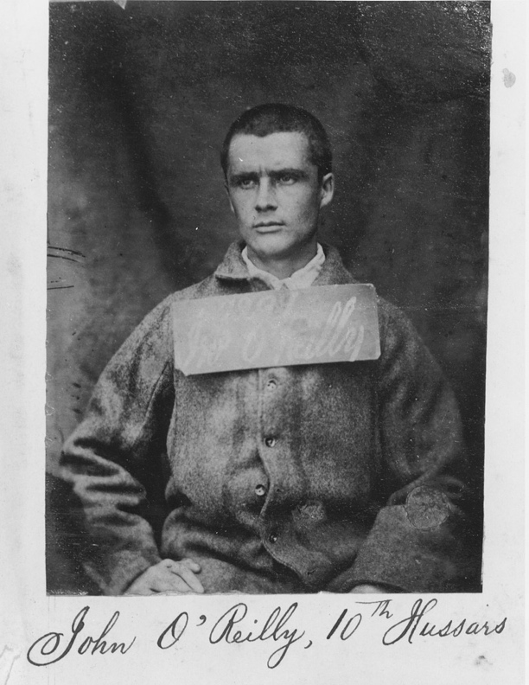
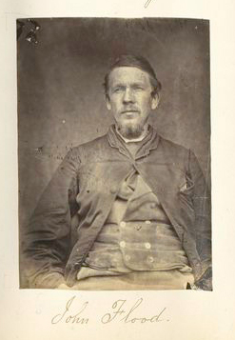
Figure 2. John Boyle O’Reilly, https://commons.wikimedia.org/wiki/File:John_Boyle_O%27Reilly.jpg?uselang=en#Licensing

Figure 1. John Flood, https://commons.wikimedia.org/wiki/File:JohnFloodConvict.jpg

Although for most tourists time on board ship was transformative, for convicts the passage of transportation did nothing to change their situation or disenfranchisement. Despite this, as will be shown throughout the rest of the article, through the pages of The Wild Goose, the convicts encouraged each other to transcend their status as prisoners and act as representatives of the Irish nation in Australia and beyond.

  - The Journey of the Hougoumont 1867-1868
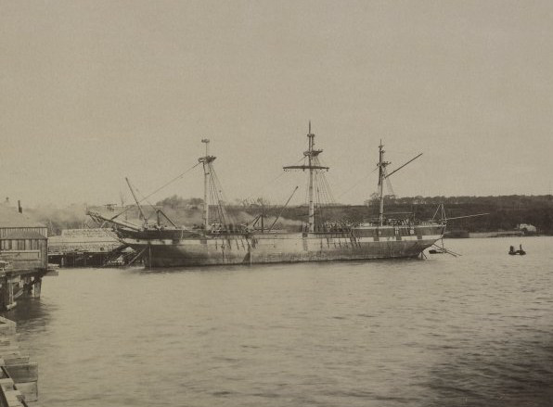
Figure 3. The ship ‘Hougoumont’ at the Forth Bridge works, https://commons.wikimedia.org/wiki/File:The_ship_%27Hougoumont%27_at_the_Forth_Bridge_works_(cropped).jpg

The voyage of the Hougoumont sits at the end of a long history of convict transport from Great Britain to its penal colonies, a time when the majority of Australian states in particular were beginning to protest against the arrival of more criminals to their land. With a prior history of involvement in the Crimean war and government assisted emigration, in 1876 the Hougoumont was chartered as a transport vessel for British prisoners bound for Western Australia. The passage was organised in response to a direct request from government officials in Western Australia for a new body of cheap labour to aid in the development of their state. Upon arrival in Freemantle the prisoners were to be put to work as hard labourers, clearing land and building roads throughout the colony.
The enforced migration of people from more ‘civilised’ areas of empire to aid in the settlement of new colonies constituted yet another means of imperial expansion. As a result of the more open nature of incarceration in such colonies, transport was often given to prisoners at a probationary stage of sentence and was thus not necessarily given to the most serious offenders.
On this journey, the Hougoumont housed close to 300 prisoners, all of whom were serving sentences from 5 years to life. Amongst them were 63 Irish prisoners all of whom had been arrested between 1865-1867 in connection with the ‘Fenian Rising’. They were mostly sentenced under the charge of ‘Treason Felony’ – a crime which encapsulated a range of activities considered seditious; from the recruitment of people to the Irish Republican Brotherhood (IRB) to attacking a captain’s residence to acquire arms.
Much like on board regular ships, historians of convict transportation have highlighted that, despite their imprisonment, due to the confined nature of the ship, there were many ways in which prisoners could create social environments on board. While more commonly this can be seen through activities such as contraband trading, the existence of the Wild Goose and a few other surviving publications show that the collaborative creation of a newspaper while on board transport ships was not out of the question.

  - The Wild Goose: A Collection of Ocean Waifs

The Wild Goose’s inception is not well documented. But, in the diary of Denis B Cashman, another Irish convict on board the ship, a series of meetings were noted to have taken place between November 1st and 5th where they “passed resolutions, appointed a chairman & finally settled to start if [they got] paper.” A shortage of supplies was something that can be evidenced across many ship-board newspapers, but the conditionality mentioned here bares more testament to their incarceration. As well as needing the approval of the captain, the sourcing of paper, pens, and ink to create the newspaper was most often provided at the grace of Father Delaney, their chaplain. This highlights the exceptionality of the publication in a period when shipboard newspapers were a well-established practice.
While its production was certainly more unusual than other shipboard publications, in many ways it sought to fill the same gap, providing structure and entertainment during the long passage. Like others, the editorial voice of the newspaper was very open about this intention – in the first issue stating, “I will aim to console you for the past, to cheer you for the present, and to strengthen you for the future.” In the following issue they encouraged “the public” to get involved in the publication more actively as a way to help overcome “monotony and melancholy – two goblins we earnestly wish to vanish.”
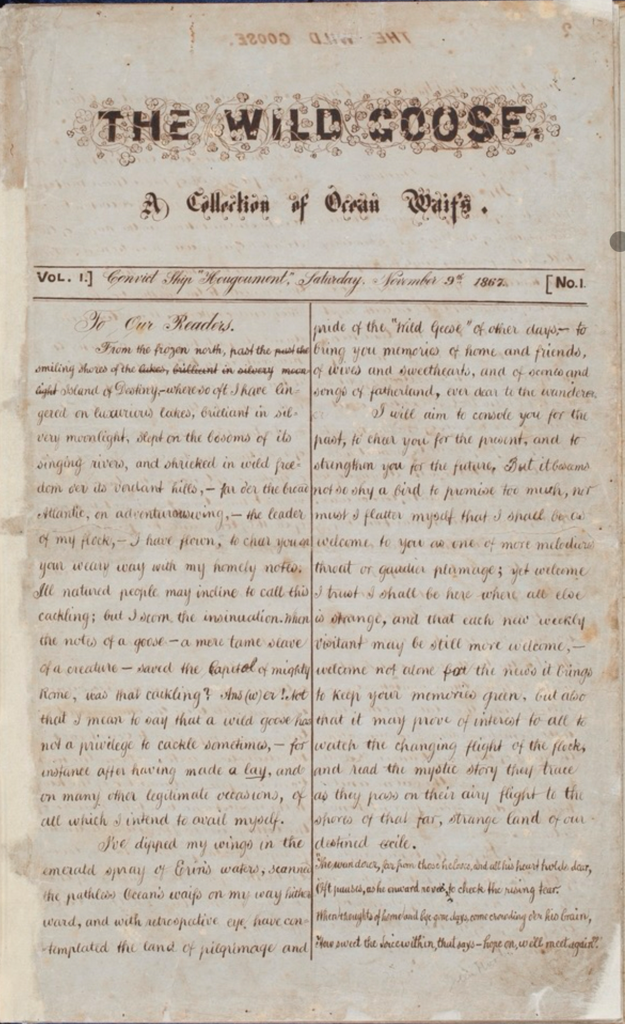
Even if the convicts didn’t contribute, they were brought into the fraternity of its pages every Saturday evening when the paper was read aloud by its editors to an audience in the no.6 mess, where they were held on board the Hougoumont. This method of ‘publishing’ is especially significant when considering the social dimension of the newspaper and impact of its messages, as it demonstrates how the Goose actively brought the men together to engage with and discuss its contents. Although the reading of the paper meant that it was inclusive of any illiterate members of the group, it also highlights how they kept it exclusive to the Irish community on board ship – just like how on other ships, newspapers that were kept in first class and saloon cabins were inaccessible to those in steerage.
ML, MLMSS1542 (Safe 1/409), The Wild Goose, Vol.1, No.1, (9th November 1867),1.

The paper was thus designed to relate specifically to their positions as Irish convicts and exiles. Yet, there were also many ways in which it sought to connect its audience with the spirits and histories of their ancestors that existed beyond the confines of the Hougoumont. This can most clearly be evidenced by the title of the paper itself – ‘The Wild Goose’ – an allusion to the Irish soldiers who went to fight in wars across Europe and the Americas. It is a metaphor that extends throughout all seven issues of the Goose and is often reflected on in its passages. For example, ‘Musings’ by John Edward Kelly (pen-name Kappa) considers how “Scarce twenty years have elapsed since others winged their way over nearly the same path…” As figures who denote a sense of national pride, the comparison of their positions is interesting to consider, as it demonstrates how they began to reconceptualise their journey abroad for much less heroic reasons. In a more direct way, the bird imagery also connotes ideas of seasonal migration patterns and freedom which also feature heavily in the paper.

  - “They’ll come again when the south winds blow”

Wider studies of shipboard newspapers have suggested that those produced on board emigrant ships were more likely to subvert the conventions of traditional newspapers, for example by blurring the lines between fact and fiction as a way of drawing attention to the present moment instead of to the worlds left behind and one about to be entered into. While The Wild Goose makes use of subversive techniques in a similar way to those of emigrant newspapers like The Alfred or The Open Sea, the content of the articles makes clear that there is no intention of grounding its audience in their present condition of imprisonment.
From the very first page of the volume, when the editorial introduces its aims, there begins a detachment from their position as exiles simply through the closing assertion that “we’ll meet again” with loved ones who they had been forced to leave behind. Although it can be read merely as a platitude, it nonetheless conveys the optimistic tone that the paper intends to keep in relation to the future prospects of its readers. It is thus also fundamentally built into the structure of the paper itself. Reinforced through the subtitle of the editorial column which appears in every paper, “They’ll come again when the south winds blow,” is a clear reference to the idea of their eventual return home to Ireland. In keeping with the paper’s goose conceit, through the repeated imagery of a bird migrating south for the winter, the audience of the newspaper is able to relate to other patterns of world travelling and thereby conceptualise themselves as free agents crossing the globe, instead of prisoners barred from returning to the place they call home.
This intention to deny the finality of their exile through the paper also comes across in an article from the first issue called ‘Australia’. It begins:
“As our readers, we presume would be grateful for a truthful account of the land to which they are going, and where they will probably sojourn for a lengthened period, we, of our great good nature, condescend to import to them some interesting particulars concerning that vast island.”
As a satirical piece purporting to give insight and advice about the country, the comedic value of the writing partially rests on the framing of their journey as any other emigrant or passenger ship travelling to Australia, which is crafted through the euphemistic characterisation of their penal sentence as a destination where they “will probably sojourn for a lengthened period.” More so than the image of the wild goose, this phrasing clearly relates their experience to that of other world travellers. Although both reference a temporary stay, a ‘sojourn’ is more commonly associated with human patterns of movement and therefore gives them more agency in the decision-making process regarding their travel as they are not subject to nature or a predetermined course.
While moments like this do not reflect the reality of transportation, it is important to consider how it served to boost the morale of the imprisoned and keep them optimistic about their future. By a later edition of the paper, when it can be presumed that the men had spent considerable time pondering their position in life as well as on board the ship, contributions from the writers more clearly reflect on their futures than lamenting the loss of their homeland. One man, under the pen-name of “Paddy from Cork” wrote “I also think God is just and merciful, and hope whispers that He may be pleased to place us once more on board some gallant bark, with brown or white canvas gaily spread to the breeze bound homeward.” This demonstrates that through the community of the newspaper and its shared narratives, prisoners were encouraged to be optimistic about their lives beyond this ship and the prospect of returning home in spite of their sentence.

  - Home Thoughts

Throughout the paper it is clear that thinking of home could, sometimes lead them to ponder their own imprisonment and lament estrangement from loved ones. Although references to home would continue through until the last issue of the Goose, it was perhaps due to the relative freshness of their departure that the first edition contained an article called ‘Home Thoughts’ which spoke directly about the experience and turmoil of remembering one’s previous life. It ends –
“The blessed hope of returning again to her genial soil, and to the dear ones we left behind, will give us strength to bear the worst; and, until then, thro’ pain, and regret, and sorrow, we will still look back and pray for her and for them with the true unswerving love only known to exiles.”
The structuring of this sentence, which begins with hints of optimism then progresses through to a sense of resignation, to some extent encapsulates the emotional journey depicted by the writer. It ultimately reflects the fragility of the collective imaginaries constructed in the Goose, and reminds us of the liminality of shipboard travel, which was particularly acute for convicts, who, upon departure, would again be faced with the harsh reality of their incarceration.
Scholarly interpretations of The Wild Goose have previously focused on writings such as this, emphasising the longing felt by the convicts for their homeland and highlighting how the distance created by being on board the ship only served to exacerbate their despair. But, as demonstrated by Barbara Hoffmann, writing about Ireland in their newspaper also allowed them to covertly express what she calls “oceanic Irish nationalism”. Although normal ship newspapers were often apolitical out of courtesy, the writers of the Goose were forbidden from and likely fearful of writing critically of the British government, due to the original nature of their crimes, and many past connections to seditious publication and writing. Despite this, the Goose continued to reference and disseminate nationalist ideas in more subtle ways, from the intricate shamrock detailing around the title to the re-telling of folk stories, literary sketches of prominent Irish landscapes and poems like ‘The Green’ by editor John Boyle O’Reilly.

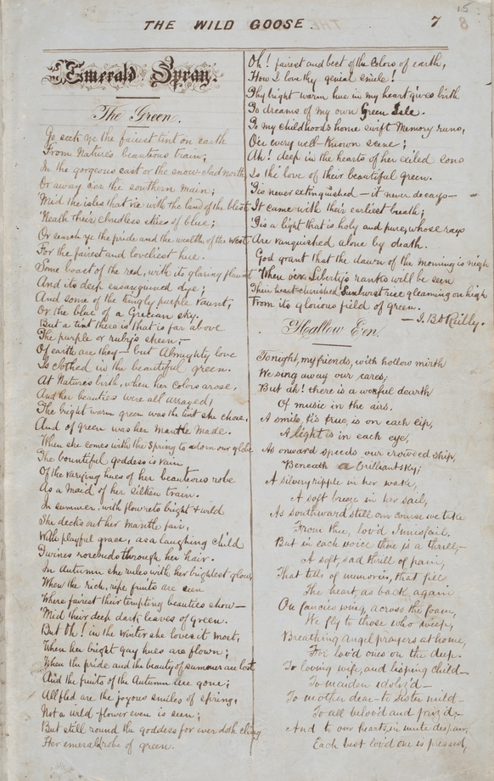
Another prominent example is an account of the 1856 4th of July celebrations written by John Edward Kelly and published over the third and fourth issues of the Goose. Born in Ireland but raised in Canada for the majority of his childhood, his parents having migrated in the early 1840s, Kelly spent a few years in Boston after completing his studies – a time from which this account was drawn. Though predominantly an indirect allusion to independence, it also makes this the comparison directly stating: “That night, sadly contrasting the position of my own country with that of the proud American republic, I fervently prayed that a happier day might dawn for my own native isle in the sea.” This highlights how at points the paper would toe the line of politicisation, aligning its values with a specifically anti-colonial nationalism that due to their shipboard freedom could be expressed and shared more openly.
ML, MLMSS1542 (Safe 1/409), The Wild Goose, Vol.1, No.2, (16th November 1867),7.

  - “Our Devil”

Similarly, the paper contains notable moments of veiled criticism and mockery of the British establishment. In order to maintain the newspapers conceit, the paper does not often reference day-to-day life aboard the ship, other passengers or crew members in the same way that more traditional ship newspapers would. In the few moments where this occurs, however, it nonetheless conceals the actual hierarchies that existed on board convict transports. To illustrate, it can be assumed that the captain is referred to in the paper as “our devil” a clear demarcation of The Wild Goose’s opposition to him. Despite being the highest authority and representative of the British government, this metaphor affords him no greater status over the public of the paper and thus embodies a subtle form of resistance against what he represents, not just as their prisoner, but the wider imperial system.
In keeping with the satirical tone which runs throughout much of the paper, this is also evident in comments made about the absurdity of the system of convict transport itself. After denouncing British colonisation of the land, another extract from John Edward Kelly’s ‘Australia’ states:
“That magnanimous government, in the kindly exuberance of their feelings, have placed a large portion of that immense tract of country at our disposal, generously defraying all expenses incurred on out way to it, and providing retreats for us there to secure us from the inclemency of the seasons and the carnivorous propensities of the natives.”
For comedic effect, this sentence significantly undermines the imperial structure that their journey is based on by euphemistically reconceptualising the facts of their trip and implying that they are being sent, not as prisoners and enemies of the crown, but as its guests of honour. It likely reflects critical discourses already shared by the group to make light of their journey and find agency despite their disenfranchisement. However, it also begins to reveal the hypocrisy buried within their anti-colonial outlook through its reference to ‘the carnivorous propensities of the natives,’ which is loaded with assumptions about civilisational and racial hierarchies.

  - “The better metal”
As demonstrated by the article ‘Forethought’ by John Flood it is clear that the group reject the use of such stereotyping. A fierce counter to the claim that Irish people are irrational and impulsive, he asserts that “both individually and as a people, we are not inferior to any action in this, or any other great quality,” and that “whole sheets” are worth being dedicated to the rectification of this assumption. In connection with their opposition to British imperialism, this supports interpretations, such as Charles Sullivan, which have argued that the convicts’ outlook should not be compared to that of other emigrants, who would have shared the colonial perspective. But, as highlighted above, they share no reservations when used at the expense of the indigenous peoples of other nations and frequently make references to their superiority over aboriginal Australians.
This most often manifested when they began to consider their futures in Australia. In the final issue of the paper, published only a few weeks before their arrival in the country, the editor addresses them with some motivational parting words stating: “You are sadly placed; but I know that your hearts are strong and that you will not be degraded by the dross with which you may be placed in contact; but like the better metal, you will come through the fire refined strengthened and purified.” This presents Australia as a place that needs to be endured and very clearly demonstrates how the paper views its audience as being made of a higher moral quality than its current inhabitants. While this doesn’t imply that they perceived themselves as part of the colonial establishment, it does suggest that they shouldn’t be seen as completely distinct as it shows how they look down on its populations with similar disdain.
Furthermore, in spite of their convict status, they conceptualise their purpose in its society as the spreading of western systems and values. This can be inferred from repeated references to the lack of development and infrastructure in Australia, such as an article titled “The Useful” which starts
“We are fast approaching, and about to become denizens of, a colony as yet in its infancy, and consequently in a not very advanced state with regard to the usual refinement of civilisation,”
and goes on to highlight how practical skills will be beneficial for their settlement in the colony. While this was a fundamental reason behind convict transport, their discussion of their role in the pages of the newspaper, which represented a separate community on board the ship, places them as active members of the development project in Western Australia and its wider civilising mission, not as reluctant and forced participants.
Through this work, they also place themselves as ambassadors of their nation, ensuring a continued connection to the cause of independence to which they had dedicated their lives. Identifying themselves as “Irishmen who’s proud privilege it is to represent our people amongst strangers,” they are encouraged to derive a high value from their displacement; to understand it as an opportunity for their country rather than a personal failure or defeat. This optimistic and entrepreneurial outlook is something which again seems inspired by the newspapers’ deep connection to previous generations of ‘Wild Geese’ as highlighted in an article called ‘Past-Present-Future’, in which discussion of their lives is significantly related to those of previous Irish exiles. Stressing the importance of their sacrifices abroad, it states “wherever they went, or in whatever duty engaged they nobly upheld the unstrained name, honor and bravery of their race.” Here, the underlying intention to demonstrate to the convicts how they would become representatives of Ireland and the republican cause when they reached Australia, is clear and emphasised by the comparison to likely familiar figures and movements.
  - Adieu
In the final issue of the newspaper, a special double Christmas edition, it was announced with regret that “in all probability the ‘wild goose’ will never speak to you again,” as they would soon be arriving at Fremantle Prison, where their privileged position on board the Hougoumont could not be guaranteed.
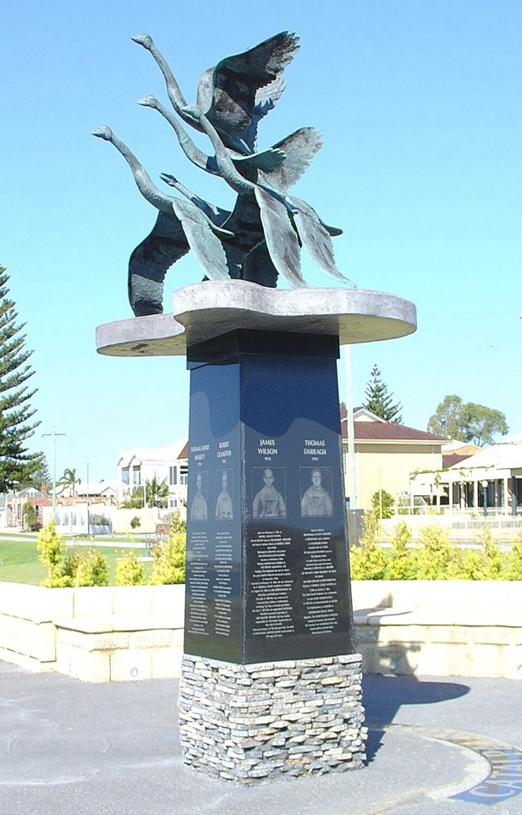
It is usually at this point when stories of these men begin, placing emphasis on the various paths taken in Australia and beyond after they disembarked on the 9th January 1868. It would not take long for groups of Hougoumont convicts to be pardoned of their crimes and allowed to return home or travel freely. But for others, especially the military prisoners, freedom seemed less achievable and so they devised plans to escape. The story of the Catalpa Rescue of 1876 has gained particular attention. Organised with the help of Goose editor John Boyle O’Reilly, who had been the first to successfully flee the prison in February 1869, it saw the escape of six men to America. Today a memorial of this event sits on Fremantle Beach, represented by a statue of six geese in flight - imagery which foregrounds their position within the wider Irish tradition as did The Wild Goose.
Catalpa monument on the Rockingham foreshore, Western Australia, https://en.wikipedia.org/wiki/File:Catalpa_monument_on_the_Rockingham_foreshore,_Western_Australia.JPG, Bjenks, 19th August 2007.
While these stories are certainly interesting, the aim of this piece has been to highlight the importance of the journey in preparing these men for their futures in Australia and beyond. As we have seen, the almost paradoxical freedom offered to the Irish prisoners during their time on board the Hougoumont allowed them to develop a community in which they could share their hopes, fears and intentions for the future, as well as hold on to the cause of Irish nationalism which united them all.

Cashman, D. B, and Charles W Sullivan (ed), Fenian Diary: Denis B. Cashman on Board the Hougoumont, (Dublin: Wolfhound, 2001), p. 73.
Johanna de Schmidt, “‘This strange little floating world of ours’: shipboard periodicals and community-building in the ‘global’ nineteenth century,” Journal of Global History, 11, (2016), pp. 229-250, (p. 232).
Ibid., pp. 237-9.; Roland Wenzlhuemer and Michael Offermann, ‘Ship Newspapers and passenger Life Aboard Transoceanic Steamships in the Late Nineteenth Century’, Transcultural Studies, 1 (2012), pp. 77-121.
De Schmidt, “‘This strange little floating world of ours’”, p. 234.
Barbara Hoffmann, “Over the Edge of the World: Irish Convict Writing and Contemporary Australian Literature,” ProQuest Dissertations & Theses, (University of Miami, 2017), pp. 11.
Sullivan (ed), Fenian Diary, p. 34.
Walter McGrath, ‘The Fenians in Australia’, Journal of the Cork Historical and Archaeological Society, 93, (1988), pp. 45-54, (p. 45).
A Global History of Convicts and Penal Colonies, ed. Clare Anderson (London, 2016), p. 13.
Anderson (ed), A Global History of Convicts, p. 22.
Sullivan (ed), Fenian Diary, p. 71.
Sydney, State Library of New South Wales, Mitchel Library (hereafter: ML), MLMSS1542 (Safe 1/409), The Wild Goose, 1867, vol.1 no.1, p. 1.
ML, MLMSS1542 (Safe 1/409), The Wild Goose, 1867, vol.1 no.2, pp. 4-5.
De Schmidt, “‘This strange little floating world,’” pp. 326-7.
ML, MLMSS1542 (Safe 1/409), The Wild Goose, 1867, vol.1 no.5, p. 2-3
Fariha Shaikh, ’The Alfred and The Open Sea: Periodical Culture and Nineteenth-Century Settler Emigration at Sea‘, English Studies in Africa, 57 (2014), pp. 21-32.
ML, MLMSS1542 (Safe 1/409), The Wild Goose, 1867, vol.1 no.1, p. 1.
ML, MLMSS1542 (Safe 1/409), The Wild Goose, 1867, vol.1 no.1, p. 8.
ML, MLMSS1542 (Safe 1/409), The Wild Goose, 1867, vol.1 no.4, p. 8.
ML, MLMSS1542 (Safe 1/409), The Wild Goose, 1867, vol.1 no.1, pp. 4-5.
Hoffmann, ’Over the Edge of the World,’ p. 11.
De Schmidt, ’”This strange little floating world’, p. 232.
ML, MLMSS1542 (Safe 1/409), The Wild Goose, 1867, vol.1 no.4, pp. 2-3.
Wenzlhuemer and Offermann, ’Ship Newspapers‘, p. 104.
ML, MLMSS1542 (Safe 1/409), The Wild Goose, 1867, vol.1 no.1, p. 8.
ML, MLMSS1542 (Safe 1/409), The Wild Goose, 1867, vol.1 no.3, pp. 4-5.
Sullivan (ed), Fenian Diary, p. 45.
ML, MLMSS1542 (Safe 1/409), The Wild Goose, 1867, vol.1 no.7, pp. 1-2.
ML, MLMSS1542 (Safe 1/409), The Wild Goose, 1867, vol.1 no.6, pp. 5-6.
ML, MLMSS1542 (Safe 1/409), The Wild Goose, 1867, vol.1 no.3, pp. 4-5.
ML, MLMSS1542 (Safe 1/409), The Wild Goose, 1867, vol.1 no.5, pp. 5.
ML, MLMSS1542 (Safe 1/409), The Wild Goose, 1867, vol.1 no.7, pp. 8-9.

